**CN vs AD – X axis (sagittal plane)**

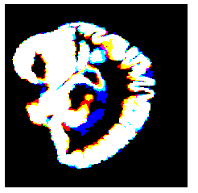

**Approach 1 - 2019_04_24_09_19**

**Network:**

Transfer learning from AlexNet changing last 3 layers.

|  |  |
| --- | --- |
| **Training parameters:**   * folds=3; * miniBatchSize = 30; * learningRate = 1e-4; * maxEpochs=24; * optimizer='sgdm'; * "L2Regularization", 0.0001 * %"Momentum", 0.889 * %'Shuffle','every-epoch' | **Dataset:**   * nPictures=6; * gap=2; * k=1; |

**Results:**

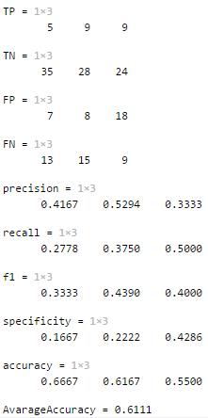

**Approach 2 - 2019_04_24_09_32**

**Network:**

Transfer learning from AlexNet changing last 3 layers.

|  |  |
| --- | --- |
| **Training parameters:**   * folds=3; * miniBatchSize = 64; * learningRate = 1e-4; * maxEpochs=20; * optimizer='sgdm'; * "L2Regularization", 0.0001 * %"Momentum", 0.889 * %'Shuffle','every-epoch' | **Dataset:**   * nPictures=6; * gap=2; * k=1; |

**Results:**

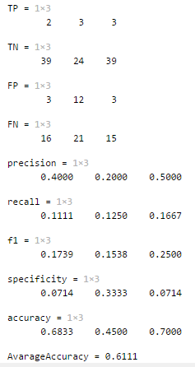

**Approach 3 - 2019_04_24_09_39**

**Network:**

Transfer learning from AlexNet changing last 3 layers.

|  |  |
| --- | --- |
| **Training parameters:**   * folds=3; * miniBatchSize = 30; * learningRate = 1e-4; * maxEpochs=40; * optimizer='sgdm'; * "L2Regularization", 0.0001 * %"Momentum", 0.889 * %'Shuffle','every-epoch' | **Dataset:**   * nPictures=6; * gap=2; * k=1; |

**Results:**

